**FEDERAL UNIVERSITY OF AGRICULTURE ABEOKUTA**

**MECHANICAL ENGINEERING DEPARTMENT**

**SWEP 2021 BATCH**

**GROUP 5**

**NAME: ADEYEMO SHERIFF ADETUNJI**

**DEPARTMENT: MECHANICAL ENGINEERING**

**MATRIC NO: 20181702**

**ASSIGNMENT**

* **Conversion of sizes from imperial (inches) to metric (mm)**

|  |  |
| --- | --- |
| **Imperial (inches)** | **Metric (millimetres)** |
| 3/8 | 9.53 |
| 1/2 | 12.7 |
| 3/4 | 19.05 |
| 1 | 25.4 |
| 1.5 | 38.1 |
| 1.25 | 31.75 |
| 2 | 50.8 |
| 2.5 | 63.5 |
| 3 | 76.2 |
| 4 | 101.16 |

* **Types of Fittings and their uses**

**1. ELBOW PIPE FITTINGS**

Elbows are used to change the direction of flow between two pipes. Elbows are generally available with an angle of 22.5o, 45o and 90o. If pipes are of same diameter then normal elbows are used otherwise Reducer elbows are used. Elbows are made of different materials. These are generally coming with female threads and we can fix them by butt or socket welding also.

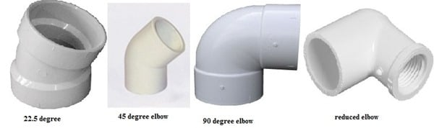

**2**. **REDUCER PIPE FITTINGS**

Reducer is a pipe fitting component which reduces the flow size from larger to smaller by reducing size of pipe. Usually there are two types of reducers are available. One is concentric reducer which is like cone shaped with gradual decreasing around the pipe but in this case accumulation of air may possible and it results in cavitation. Other one is eccentric reducer which is having one edge parallel to connecting pipe due to which air accumulation is not possible.

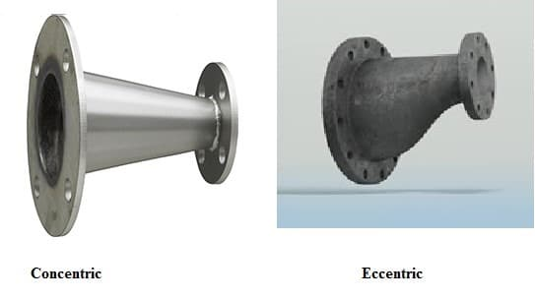

**3. TEE TYPE PIPE FITTINGS**

Tee type fitting is a component of plumbing system which is in T-shape. It is having one inlet and two outlets, outlets are arranged at 90o to the main line connection (inlet). It can also be used to combine the flow from two inlets to one outlet. They are also available in different materials and different sizes. If the 3 sides of T-fitting are similar in size then it is called as Equal tee otherwise it is called as Unequal tee.

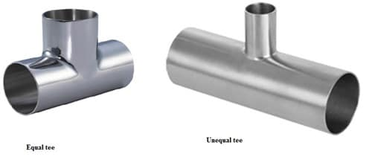

**4. CROSS TYPE**

Cross type fittings contains 4 opening in 4 directions. These are connected when there are 4 pipes are meeting at a point. These fittings generate more amount of stress on pipe as the temperature changes, because they are located at the center of four connection points. Cross fittings are generally used for fire sprinkler sy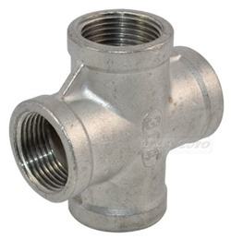stems.

**5. COUPLING**

A coupling is used to connect the pipes of same diameter. Coupling are also useful if the pipe is broken or leakage occurs. Generally there are two types of couplings are available. Compression coupling and slip coupling. Compression coupling is regular coupling which is connected between two pipes and it prevents leakage by the arrangement of gaskets or rubber seals on both sides, otherwise glue is provided. Slip coupling is easier to install and it contains two pipes which are arranged as one into other, inner pipe can slide up to some length. So, we can fix long length damaged pipe by slip coupling.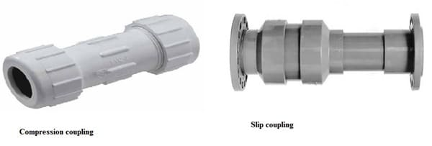

**6. UNIONS**

Union is a type of fitting, which functions as similar to coupling. But coupling cannot be removed after fixing but in this case we can remove the union whenever we needed. Unions consists nut, male and female ended threads. So, this is also useful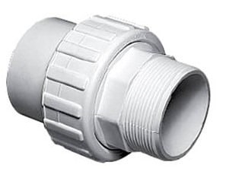 for maintaining purpose of pipe.

**7. ADAPTORS**

If the pipes are not having special ends or plain ends then adaptors make them threaded either male or female whichever is needed. Adopters are generally used for copper and PVC pipes. Male adapters contain male threads and female adapters contains female threads. One end of adapter is plain which is glued or welded or soldered to the plain pipe end.

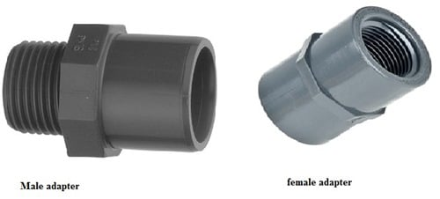

**8. OLET**

Olets are used when there is standard sizes of fittings are not suitable for our requirement. Sometimes the inlet pipe size is larger compared to outlet pipes in t-sections then also Olets are used. There are many types of olets are available. Some important types of olets are:

Butt-Weldolet, Socket weld Olet, Threaded olet, Elbow olet, Nipple olet, Lateral olet, Sweepolet, Flange ole.

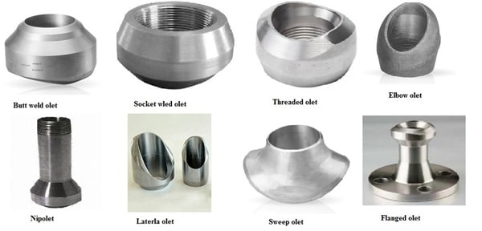

**9. PLUG**

Plug is a component of plumbing component which is generally used to close pipe opening during inspections and repairs. Plug are generally contains male threads.

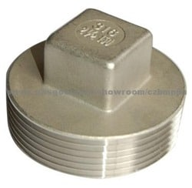

**10. CAP**

Cap is a type of pipe fitting which function is same as plug but the only difference is plug contain male threads and cap contain female threads which is screws on the male thread of pipe. These are available in different materials like rubber, copper, steel, plastic etc.

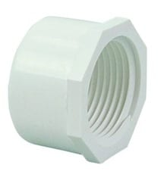

* **Types of valves and their uses**

**1. GATE VALVE**

These valves are the most common types of valves and are a linear motion valve used to start or stop fluid flow and these valves are fully closed or fully open positions. In almost all fluid services such as air, fuel gas, feedwater, steam, lube oil, hydrocarbon, etc gate valves are used and these valves provide good shutoff. These valves are also used in wastewater plants, food processing facilities, and process plants.

**2. GLOBE VALVE**

To stop, start, and regulate the fluid flow globe valve is used and also used in the systems where flow control is required and leak tightness is also required. As compared to the gate valve the globe valve provides better shut off and it is costlier. Depending on the requirements of the installation these types of valves can seal against the fluid flow.

**3. CHECK VALVE**

In the piping system, the check valve prevents backflow and these types of valves permit fluid to flow through them in one direction only. For high-pressure applications, these types of valves are also suited. As globe valves, Lift-type check valves are similarly constructed and use a ball or piston and often backed by a spring that opens under a specified pressure but it presents backflow as the pressure decreases. When multiple gases are mixed into one gas stream check valves are also used and to prevent mixing of the gases in the original source a check valve is installed on each of the individual gas streams.

**4. PLUG VALVE**

These types of valves are a Quarter-turn rotary motion valve that uses a cylindrical or tapered plug to start or stop the flow and the disk has a passage to pass the flow and is in plug shape. As on-off stop valves plug valve is used and also efficient of providing bubble-tight shutoff and to high-pressure & temperature applications, plug valve can be used in a vacuum. For the chemical process industries, processing plants, and wastewater treatment facilities, these types of valves are used for shut-off and are used as control valves.

**5. BALL VALVE**

These types of valves are a quarter-turn rotary motion valve that uses a ball-shaped disk to start or stop the flow and to operate the valve, most ball valves are of the quick-acting type which requires a 90° turn of the handle.These valves are smaller and lighter than a gate valve and for flow and pressure control and shut off for corrosive fluids, slurries, normal liquid, and gases, ball valves are used.

**6. BUTTERFLY VALVE**

This valve is a quarter-turn rotary motion valves and the specification of this valve includes port connection, valve size, and the materials that make up the valve body, its seat, seal, stem packing, and disc. To stop, regulate, and start the flow, these types of valves are used and for large valve applications due to compact, lightweight design that requires considerably less space butterfly valve is also suitable.

**7. HYDRAULIC VALVE**

To control fluid flow in hydraulic fluid power systems hydraulic valves are used and these types of valves are mechanical or electro-mechanical devices. In stationary systems, they are actuated electrically and in mobile systems, they are actuated manually. The specifications of this valve include valve type, actuator type, port connections, number of ports, port configuration, pressure ratings, and materials of construction. On construction machines like backhoes, loaders, etc, and also in an abundance of stationary systems such as balers and presses, these types of valves are used.

**8. NEEDLE VALVES**

Needle valves have sharp needle-like a disk and are similar to a globe valve in design and these types of valves are designed to give very accurate control of flow in small diameter piping systems. In vacuum systems and for metering systems where precise flow regulation is required, needle valves are used.

**9. PINCH VALVE**

Pinch valve is a linear motion valve used to start, regulate, and stop fluid flow and also called a clamp valve. To control the fluid pinch valve uses a rubber tube and a pinch mechanism. For the handling of slurries, liquids with large amounts of suspended solids and systems that convey solid material pneumatically, these types of valves are ideally suited.

**10. DISC VALVE**

To control flow through a pipe these types of valves are used and consist of a round flat plate mounted to the end of a stem that enters the pipe at 45 degrees. In food processing applications, disc valves are almost exclusively found. In the food, pharmaceutical, and dairy industries these valves are used.

* **Types of pipes**

**1. BRASS PIPES**

Brass pipe is an alloy of copper and zinc. It is widely utilized in and for many household items like locks, bearings, doorknobs and plumbing applications such as tubes such as the one shown below. While brass may be used for plumbing pipes, it rarely is because of it being very expensive. Brass fittings are more common.

**2. CAST IRON PIPE**

Cast Iron pipe is popular for city water-distribution systems due to its high resistance to corrosion and consequent long life. Cast iron pipe is made of pig iron. Such pipes are generally made from 5 cm to 120 cm in diameter. Under normal conditions, a cast-iron pipe could be expected to last 100 years. The usual length of a pipe section is 12 feet, but lengths up to 20 feet may be obtained. Cast iron pipe is made in several wall thickness classes for various pressures up to a maximum of 350 psi.

**3. PVC PIPES**

PVC stands for polyvinyl chloride. Also, it has become a common replacement for metal piping. PVC (Polyvinyl Chloride) is one of the best-known pipe options. PVC is synonymous with “pipe”. It is widely utilized in residential plumbing for waste drainage and vent applications.

**4. GALVANIZED STEEL PIPES**

Galvanized steel is coated with zinc to prevent rust. This type of pipe has been popular in houses built before 1960 – replaced lead pipes for water lines. The problem with galvanized steel pipes would be eventually the zinc coating erodes which then results in rust

**5. COPPER PIPES**

Copper pipes are made of small diameter. Since copper doesn’t admit rust, therefore these pipes are durable.However, as copper is costly; therefore, they’re used in limited places. These kinds of pipes are usually used to carry hot water or steam. They don’t bend or sag even in high temperatures. Copper is a mild metal.Therefore, copper pipes may be bent easily. They are joined by Union Joints and Flanged Joints.